***Session 3: Exploring Mapreduce***

***Assignment 3.1***

**Hadoop 2.x Components**

* Hadoop Common Module is a Hadoop Base API (A Jar file) for all Hadoop Components. All other components works on top of this module.
* HDFS stands for Hadoop Distributed File System. It is also know as HDFS V2 as it is part of Hadoop 2.x with some enhanced features. It is used as a Distributed Storage System in Hadoop Architecture.
* YARN stands for Yet Another Resource Negotiator. It is new Component in Hadoop 2.x Architecture. It is also know as “MR V2”.
* MapReduce is a Batch Processing or Distributed Data Processing Module. It is also know as “MR V1” as it is part of Hadoop 1.x with some updated features.
* Remaining all Hadoop Ecosystem components work on top of these three major components: HDFS, YARN and MapReduce.

**Hadoop 2.x Major Components**

Hadoop 2.x has the following three Major Components:

* HDFS
* YARN
* MapReduce

These three are also known as Three Pillars of Hadoop 2. Here major key component change is YARN. It is really game changing component in BigData Hadoop System.

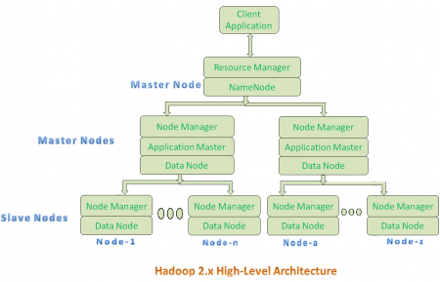

* All Master Nodes and Slave Nodes contains both MapReduce and HDFS Components.
* One Master Node has two components:
  1. Resource Manager(YARN or MapReduce v2)
  2. HDFS

It’s HDFS component is also knows as NameNode. It’s NameNode is used to store Meta Data.

* In Hadoop 2.x, some more Nodes acts as Master Nodes as shown in the above diagram. Each this 2nd level Master Node has 3 components:
  1. Node Manager
  2. Application Master
  3. Data Node

**Resource Manager:**

* Resource Manager is a Per-Cluster Level Component.
* Resource Manager is again divided into two components:
  1. Scheduler
  2. Application Manager
* Resource Manager’s Scheduler is :
  1. Responsible to schedule required resources to Applications (that is Per-Application Master).
  2. It does only scheduling.
  3. It does care about monitoring or tracking of those Applications.

**Application Master:**

* Application Master is a per-application level component. It is responsible for:
  1. Managing assigned Application Life cycle.
  2. It interacts with both Resource Manager’s Scheduler and Node Manager
  3. It interacts with Scheduler to acquire required resources.
  4. It interacts with Node Manager to execute assigned tasks and monitor those task’s status.

**Node Manager:**

* Node Manager is a Per-Node Level component.
* It is responsible for:
  1. Managing the life-cycle of the Container.
  2. Monitoring each Container’s Resources utilization.

**Container:**

* Each Master Node or Slave Node contains set of Containers. In this diagram, Main Node’s Name Node is not showing the Containers. However, it also contains a set of Containers.
* Container is a portion of Memory in HDFS (Either Name Node or Data Node).
* In Hadoop 2.x, Container is similar to Data Slots in Hadoop 1.x. We will see the major differences between these two Components: Slots Vs Containers in my coming posts.
* Both Hadoop 1.x and Hadoop 2.x Architectures follow Master-Slave Architecture Model.